**Second Review Document**

**Next-Gen Balance Management System**

**Name : Komal Gulati**

**Reg. No. : 17BCE0596**

**Mobile Number : 9535965303**

**Mail ID : komal.gulati2017@vitstudent.ac.in**

**Guide Name : Dr.Sendhil Kumar K. S.**

**Designation : Associate Professor-SCOPE**

**Mobile Number : 9840068152**

**Mail ID : sendhilkumar.ks@vitstudent.ac.in**

**B.Tech.**

in

**Computer Science and Engineering**

**School of Computer Science & Engineering**

**®**



Table of Contents

1. Introduction 4

1.1. Theoretical Background 4

1.2. Motivation 5

1.3. Aim of the proposed Work 5

1.4. Objective(s) of the proposed work 5

2. Literature Survey 5

2.1. Survey of the Existing Models/Work 5

2.2. Summary/Gaps identified in the Survey 6

3. Overview of the Proposed System 7

3.1. Introduction and Related Concepts 7

3.2. Framework, Architecture or Module for the Proposed System 7

3.3. Proposed System Model 8

4. Proposed System Analysis and Design 10

4.1. Introduction 10

4.2. Requirement Analysis 10

4.2.1. Functional Requirements 10

4.2.1.1. Product Perspective 10

4.2.1.2. Product features 10

4.2.1.3. User characteristics 10

4.2.1.4. Assumption & Dependencies 10

4.2.1.5. Domain Requirements 10

4.2.1.6. User Requirements 11

4.2.2. Non-Functional Requirements 12

4.2.2.1. Product Requirements 12

4.2.2.1.1. Efficiency (in terms of Time and Space) 12

4.2.2.1.2. Reliability 12

4.2.2.1.3. Portability 12

4.2.2.1.4. Usability 12

4.2.2.2. Organizational Requirements 12

4.2.2.2.1. Implementation Requirements 12

4.2.2.2.2. Engineering Standard Requirements 12

4.2.2.3. Operational Requirements 13

4.2.3. System Requirements 13

4.2.3.1. H/W Requirements 13

4.2.3.2. S/W Requirements 13

5. Results and Discussion 14

5.1. Account Opening 14

5.2. Deposit Money 15

5.3. Withdrawal Money 16

5.4. Account Balance Inquiry 17

5.5. jMeter Tool – Performance Measurement 18

6. References 19

# Introduction

## Theoretical Background

As per Reserve Bank of India (RBI), digital payment volumes have grown at a compounded annual growth rate of 55.1 per cent, from 5.93 billion transactions in the year to March 2016 to 34.35 billion transactions in the year to March 2020.

Some of the traditional account balance systems are either not able to meet the load or require much higher infrastructure which is making total cost of ownership as very high.

Traditional account balance system uses relational databases like Oracle / Postgres (RDBMS).

Many banks use Centralized database across country and also use same database for transactions as well inquiry / reporting.

The huge number of volumes puts a lot of load on the database. Online transaction processing thus becomes slow.

On other hand applications were not designed to handle such volumes.

In general applications update the balance table in database for every transaction along with insert into transaction table. As each transaction needs to lock the database row for balance, it is not possible to perform hundreds of transactions (debit or credit) on same account in same second. This is one of the major bottlenecks.

Second issue is as balance and transaction tables have lot of indexes insert and update of these tables becomes slow. Online API to debit (dr) or credit (cr) the account is not able to respond in less than 100 ms.

## Motivation

The challenge to solve the current problem itself is the motivation, as engineering finally is to solve the real challenges.

## Aim of the proposed Work

The aim of the proposed solution is handling huge transaction volumes with low latency (response time).

Additionally, there should be minimum disruption to the current system when new system is deployed. Banks may take some time to completely move to the new system and reture the old system, so need of hour is new system should be able to coexists with old system.

## Objective(s) of the proposed work

Objective is to ensure withdrawal and deposits can be performed with very quick response time, and higher throughput. Bank should be able to process more than 50 transactions on same account, currently this limit is around 10.

New system should ensure the transaction integrity, and should persist the transactions completely on disk before sending the response. Response cannot be sent just based on in-memory processing.

# Literature Survey

## Survey of the Existing Models/Work

In today's complex world, due to the increasing use of web-based programs, smart phones and social networks, production rate is increasing constantly as well as volume of data. Also, companies try to provide their services with more features in order to stay ahead of their competitors. That increases the production of information by the users too. In this case, it seems that moving from rational databases to non-relational databases in a necessity. With regard to the various of use cases and their requirements, also the primary features of NoSQL databases, choosing the most appropriate NoSQL database can be big concern of developers. The right selection of NoSQL databases will avoid to wasting time, money, and energy.

As organizations increasingly leverage applications hosted on different infrastructure, in different geographies, and with different providers, the speed at which end users can access those applications comes under pressure.

By leveraging a data layer that unifies your data across clouds and the globe, organizations can overcome some of the inherent limitations that have challenged technology teams for decades and deliver better experiences to their end users. different providers, the speed at which end users can access those applications comes under pressure.

**RESEARCH PAPER 1-**Analysis of REST API Implementation (2018)

Author-Chaitanya Mukund Kulkarni, Prof. M. S. Takalikar

**Abstract-**

The motivation of this paper is to design the method for api validation. Method checks if the implementation is developed as per the requirements of the specification document of the respective api. This paper also studies the challenges in analysis of the REST api and validation of the api implementation. The system will be helpful in lot of ways to analyse the REST api implementation. Proposed system can be used for complex web service. The approach described can also be used to check whether the implementation and document follows REST standards and if it is REST compliant or not.

**RESEARCH PAPER 2-** Centralized Database: A Prerequisite for Security and Sustainable Development in Nigeria(January 2017)

Author-Abubakar Mohammed, Bashir Maina Saleh

**Abstract-**

The volume of data organizations and government agencies usually collect and store are increasing rapidly. Centralized database stores data or information in a particular location within a network. It allows data from existing database to be collected and stored in a single database for sharing, analysis or updating in an organisation. Therefore, this paper highlights the need for centralised database that can be adopted by government to control data redundancy and inconsistency for security and sustainable development.With centralized database, government can access citizens’ data or records and use it for decision making whenever the need arise.

**RESEARCH PAPER 3-** Towards Scalable and Reliable In-Memory Storage System: A Case Study with Redis(2016)

Author-Shanshan Chen*∗†*, Xiaoxin Tang*∗*, Hongwei Wang*∗*, Han Zhao*‡* and Minyi Guo*∗*

**Abstract-**

In recent years, in-memory key-value storage systems have become more and more popular in solving real-time and interactive tasks. Compared with disks, memories have much

higher throughput and lower latency which enables them to process data requests with much

higher performance. However, since memories have much smaller capacity than disks, how to

expand the capacity of in-memory storage system while maintain its high performance become a crucial problem. At the same time, since data in memories are non-persistent, the data may be lost when the system is down. In this paper, there is a case study with Redis, which is

one popular in-memory key-value storage system.A lightweight Client-side Key-to-Node Caching method that can help the client to find the right node to connect to is used. Experimental results show that this method has made Redis more scalable and can improve its performance by up to 2 times.

**RESEARCH PAPER 4-** A Distributed Redis Framework for Use in the UCWW

Author-Zhanlin Ji1, Ivan Ganchev1, M´airt´ın O’Droma1, Tiefan Ding

**Abstract-**

The performance of data access plays an important role for the applications of the emerging ubiquitous consumer wireless world (UCWW). As a ‘Not only SQL’ (NoSQL) database, Redis has been deployed in the UCWW cloud as an open-source key value store acting as the key component in the system. Given the limited performance of a single Redis node, to improve the system’s performance and handle large amounts of requests from the web applications in the UCWW system, a distributed Redis framework has been designed and is proposed in this paper.

The results show that the designed Redis framework is able to run in a distributed fashion within a UCWW environment.

**RESEARCH PAPER 5-** An Efficient Approach For Concurrency Control In Distributed Database System(October 2013)

Author-Md. Tabrez Quasim

**Abstract-**

Concurrency Control is the activity of coordinating concurrent access to a database in a multiuser database management system(DBMS) .Concurrency control permits users to access a database in a multi-programmed fashion while preserving the illusion that each user is executing alone in a dedicated system. Devising a concurrency control technique that has both a low lost opportunity cost and low restart cost is a hard problem This research paper explored a hybrid architecture that provides locking for high conflict data items and optimistic access for the rest .

“.The combination of the results suggest that “ optimistic locking “ where transactions lock remote copies of data only as they enter into the commit protocol (at the risk of end- of –transaction deadlocks) may actually be the best performer in a replicated database where messages are costly .

**RESEARCH PAPER 6-** A Study of NoSQL Database

Biswajeet Sethi, Samaresh Mishra, Prasant ku. Patnaik(April 2014)

**Abstract-**

Some of the applications of web service 2.0 need big data handling. This requires the existing relational database to scale horizontally in order to achieve demand for high

performance, especially for applications which require high scale of user data and of high concurrency. These issues are important consideration for designers to come up with a new

group of databases, popularly known as NoSQL. The growing demand for cloud computing and the development of Internet motivates the NoSQL movement. This paper deals with features

and data models of NoSQL databases used in cloud computing environment along with strength and limitation of each of the model. In addition this paper talks about classification of

NoSQL databases based upon CAP theorem. This paper describes the limitation of relational database along with different categories of NoSQL data models which needs more work in future.

**RESEARCH PAPER 7-** An Analysis of Public RESTWeb Service APIs

Andy Neumann, Nuno Laranjeiro, Jorge Bernardino(June 2018)

**ABSTRACT-**

Businesses are increasingly deploying their services on the web, in the form of web applications, SOAP services, message-based services, and, more recently, REST services. This paper goes through the *Alexa.com* top 4000 most popular sites to identify precisely 500 websites claiming to provide a REST web service API analyses these 500 APIs for key

technical features, degree of compliance with REST architectural principles (e.g., resource addressability), and for adherence to best practices (e.g., API versioning). Several trends (e.g., widespread JSON support, software-generated documentation) were observed, but, at the same time, high diversity in services, including differences in adherence to best practices, with only 0.8% of services strictly complying with all REST principles. The results can help practitioners evolve guidelines and standards for designing higher quality services and also understand deficiencies in currently deployed services. Researchers may also benefit from the identification of key research areas, contributing to the deployment of more reliable services.

**RESEARCH PAPER 8-** A History and Future of Web APIs(January 2014)

Dr. Jacek Kopeck´, Mr. Paul Fremantle, Dr. Rich Boakes

**ABSTRACT-**

Distributed information systems predominantly have client-server architectures, as does the Web itself. This article reviews the evolution of the interface of client-server distributed systems, from Messaging and RPC systems that predate the Web, to RESTful Web APIs and highlights the often overlooked importance of the client-server interface inWeb applications, and references historic and current systems to discuss the roles of “Web Service” technologies and Service-Oriented Architectures. Considering the future, four directions are pointed out in which we can see Web APIs moving, including the incorporation

of hypermedia and semantics.

**RESEARCH PAPER 9-** A Novel Redis Security Extension for NoSQL Database Using Authentication and Encryption(2015)

Asadu lIa Khan Zaki, diramma M.

**ABSTARCT-**

Unlike the conventional databases, Redis does not provide enough security for the data.

Anyone can get the value if the key is known because the data is stored in the form of key value pair. Therefore such a database is unsuitable for enterprise and most practical

application data. In this paper, the work is carried out to add immense security to a Redis system using following:

a) Authentication Service b) Encryption Services c) Security to persistent data d) Security to blob data (multimedia data for images). The Encryption algorithm plays a very important role in the field of Database Management System. Here AES algorithm is used because the AES algorithm consumes least Encryption and Decryption time in comparison with RSA and

DES . Thus the proposed system extends the capabilities of the Redis system to complete multiuser scalable and secured database which can be used for real time

applications.

**RESEARCH PAPER 10-** NoSQL Databases: Critical Analysis and Comparison(2017)

Adity Gupta, Swati Tyagi, Nupur Panwar, Shelly Sachdeva, Upaang Saxena

**ABSTRACT-**

This paper explores and differentiates between various forms in which NoSQL databases exist. It examines the need of NoSQL and how they have become an important alternative to relational databases. NoSQL databases can be categorized into four major classifications which are: key value stores, graph databases, wide column stores, and document stores. Then for further analysis, one database is selected from each of these categories that is, MongoDB (document stores), Cassandra (wide column stores), Redis (key value stores), and Neo4j (graph databases). Selected databases are compared on their data model, CAP theorem, distributive properties and other factors. The comparison between MongoDB, Cassandra, Redis and Neo4j concluded that all of them follow horizontal scaling and are schema free. Except Neo4j, others don’t have complete ACID properties. Write and delete operations are fast for databases MongoDB, Redis and Cassandra, whereas read operation is comparatively slow in Cassandra. In case of Neo4j, REST performance is similar to MongoDB, whereas embedded is comparatively slow. We also discuss how these databases work in a distributed environment.

**RESEARCH PAPER 11-** Research on the Improvement of the Concurrency Control Protocol for RealtimeTransactions(2010)

Wu Peng,Pang Zilong

**ABSTRACT-**

The traditional lock-based concurrency control mechanism which focuses on the data’s consistency and the transactions’ concurrency cannot meet the demand that the

real-time database systems make on the temporal consistency. After the improvement of the concurrency control protocol for real-time transactions, this paper presents a new concurrency control method which is based on the locking, multi-version and valid confirmation concurrency control mechanisms. This method can adopt different concurrency control mechanisms according to the idiographic situation. In this way it can effectively improve the concurrency of transactions and increase the amount of the transactions completed within the deadline. The feasible analysis denotes that this new method is better than the traditional one on performance.

**RESEARCH PAPER 12-** API Usage in Descriptions of Source Code Functionality(2017)

Paige Rodeghero, Collin McMillan, and Abigail Shirey

**ABSTRACT-**

This paper presents a study exploring the use of API keywords within method summaries. A web based was conducted where participants were asked to rank Java method

summaries based on five levels of detail, from low level to high level. It found that programmers widely use API in both high and low level summaries. This also shows that, in general, as the detail level decreases, the number of API keywords within the summary increases. It explored two research question aimed at understanding this existence of API

keywords in these summaries. These findings lead us to believe that a key distinction between a high level and low level method summary is the number of API keywords that are

present.

**RESEARCH PAPER 13-** Automated API Testing(2018)

Isha,Revathi,Abhinav Sharma

**ABSTRACT-**

Application programming interface, or API, is a piece of code that enables two software components to interact. The number of APIs are expanding exponentially with every year. Thus, directing automated tests on the APIs has turned into a pivotal step in software development process since malfunctioning or ineffective APIs can result in lower acquisition of product and ultimately loss in revenue. API testing is crucial to ensure functionality, reliability, security and delivery of business logic. Major challenges faced during automated API testing include sequencing API calls, comparing unpredictable response, handling planned failed test cases, parallel API execution and handling parameter reliance. This paper presents proposed automated API testing tool and literature survey of automated API testing.

**RESEARCH PAPER 14-** Performance Analysis of Queries in RDBMS vs NoSQL(2019)

Sirish Shetty B,Akshay KC

**ABSTRACT-**

Due to the enormous amount of information getting stored in databases, an extra effort is needed to handle the information so that it is not lost in any way. To avoid the loss

of information various methods were introduced and one such technique is introduction of NoSQL using MongoDB. In this paper, a comparison is made between structured Oracle and

an unstructured MongoDB, with few identified operations in a controlled environment. The result obtained is then used to realize better performance of the structured or unstructured methods. Considering the data set which was taken for the experiment, it can be verified from the hypothesis testing that, MongoDb performs better only for insert, delete and select operation, whereas for update operation Oracle still performs better in the given environment.

**RESEARCH PAPER 15-** A web service based on RESTful API and JSON Schema/JSON Meta Schema to construct knowledge graphs(2018)

Adam Agocs,Jean-Marie Le Goff

**ABSTRACT-**

This paper presents how the combination of two powerful technologies namely the REST architecture style and JSON Schema/JSON Meta Schema enable data scientists to use a RESTful web service that permits the construction of knowledge graphs, one of the preferred representations of large and semantically rich networks. It presents the architecture of a novel RESTful web service that combines the JSON-based REST architecture style with JSON Schema/JSON Meta Schema in order to enable the construction of knowledge graphs.

## Summary/Gaps identified in the Survey

Most solutions found in survey purely depend upon in memory database, or noSQL databases. They do not provide the persistent and reporting capability of RDBMS. They do not have ACID property of the database, they provide eventual consistency, which is not acceptable for banking account balances. So, either we get the speed, or functionality, bank needs both.

# Overview of the Proposed System

## Introduction and Related Concepts

A new balance management system will be developed, which will utilize the power of in-memory REDIS database in addition to that of RDBMS. No bank will agree to depend purely upon in memory database for financial transactions. Design will ensure that the combination of RDBMS and in memory will deliver faster performance due to REDIS, but still have persistent and transaction integrity benefits of RDBMS.

Asynchronous and bulk processing will be used to remove the bottleneck of RDBMS.

## Framework, Architecture or Module for the Proposed System

In the proposed architecture, new Balance Management System will perform update of balance in REDIS, instead of database. Insert of transaction will be done in new transaction table which will have only 2 to 3 indexes.

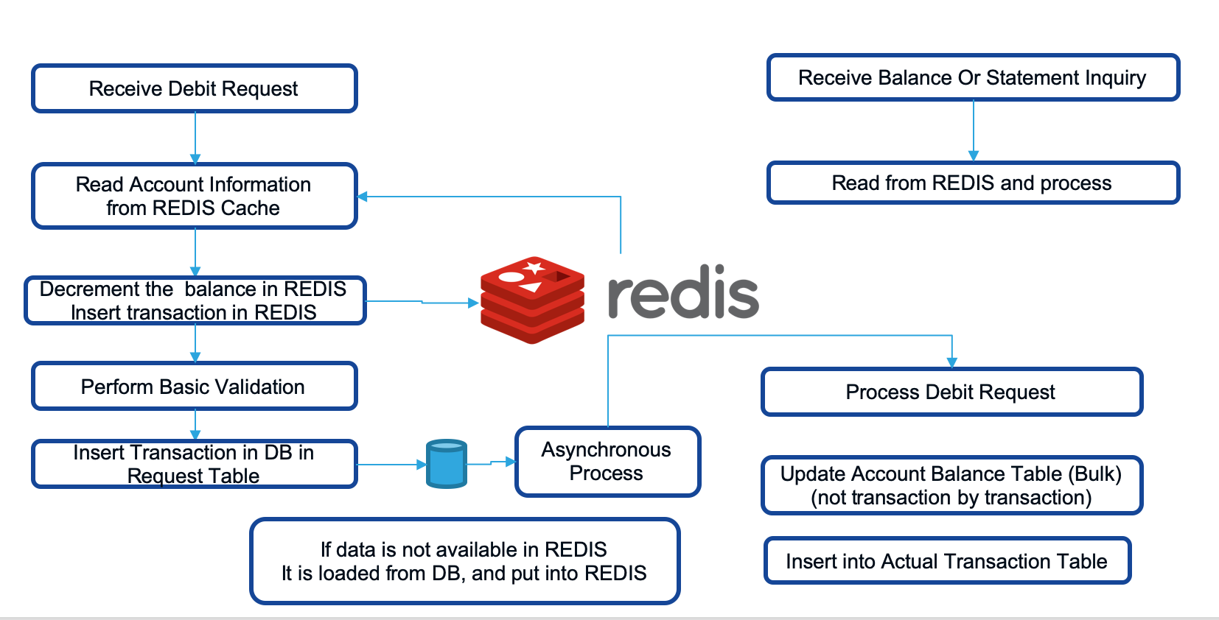

For inquiry or reporting purpose data will be inserted from new transaction tables to old transaction tables in bulk. DBMS performs better when data is written in bulk instead of transaction by transaction. Number of updates will reduce for those accounts where lot of transaction happens in same second.

## Proposed System Model



Sequence Diagram (Withdrawal)

x

Sequence Diagram (Deposits)



ER Diagram

# Proposed System Analysis and Design

## Introduction

The main design concentrates on mixing REDIS and RDBMS usage. Additionally, the design is different for withdrawal and deposits type of transactions. Bank always wants to play conservative when it comes to withdrawal. On other hand bank need not put the overhead of debit, in case of deposits.

## Requirement Analysis

## Functional Requirements

## Product Perspective

This solution can be productized as this is required by all banks. There is huge reuse of the solution. It can work on top of any banking solution.

## Product features

The important features are

* Support Withdrawal
* Support Deposit
* Support Transfer of funds.

## User characteristics

From user prospective, there need not be change in current interface or functionality.

It is more of performance and scalability of the solution which matters.

## Assumption & Dependencies

The current solution also will be able to invoke APIs / Methods to get or update the data in REDIS.

## Domain Requirements

Most important domain requirements are listed below

* Debit to Account should not be allowed for amount more than the balance or limit allocated to the account.
* It should be possible to put daily withdrawal limit check
* It should be possible to put a limit on number of withdrawals in a month

## User Requirements

Most important user requirements are

* User should see the balance amount after the withdrawal or deposit into account
* Mini statement after the transaction should include the current transaction.

## Non-Functional Requirements

## Product Requirements

## Efficiency (in terms of Time and Space)

The response time of transaction should be less than 50 ms. This response time is measured within the data center. This does not include network latency to the data center.

## Reliability

The response time of transaction should be less than 50 ms. This response time is measured within the data center. This does not include network latency to the data center.

## Portability

System is portable on any unix server, however the development and testing will be done only on linux platform in current scope.

## Usability

The response time to the user should be very less.

## Organizational Requirements

## Implementation Requirements

Multiple Linux server will be required for high availability to run REDIS clouster.

## Engineering Standard Requirements

Standard API gateway / firewall / security components will need to be deployed with proper authentication and authorization features..

## Operational Requirements

Monitoring tool will be required to monitor the REDIS, database and application.

Log collector and monitoring will be required.

## System Requirements

## H/W Requirements

For development and testing, a single linux machine is enough, with small CPU / Memory requirements as given below.

Number of Cores : 2

Memory : 4GB.

For production it will depend upon transaction and account volumes.

## S/W Requirements

Following software are required by the application.

* Java / Spring Boot framework
* REDIS (Version 5 and above)
* Postgres / Oracle RDBMS

# Results and Discussion

## Account Opening

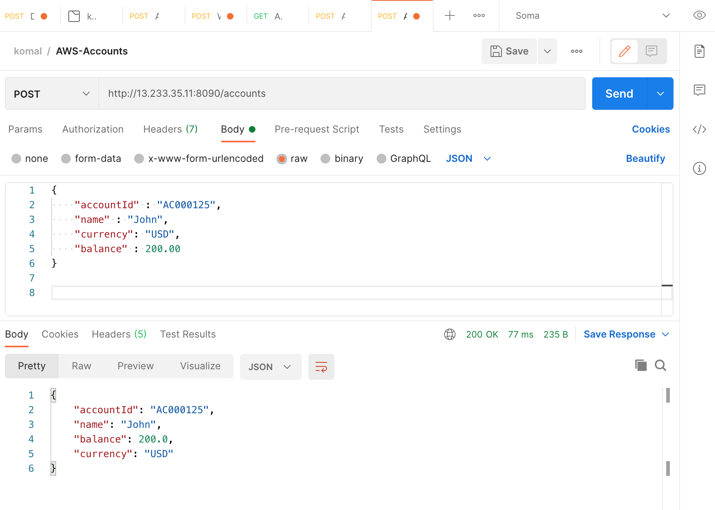

## Deposit Money

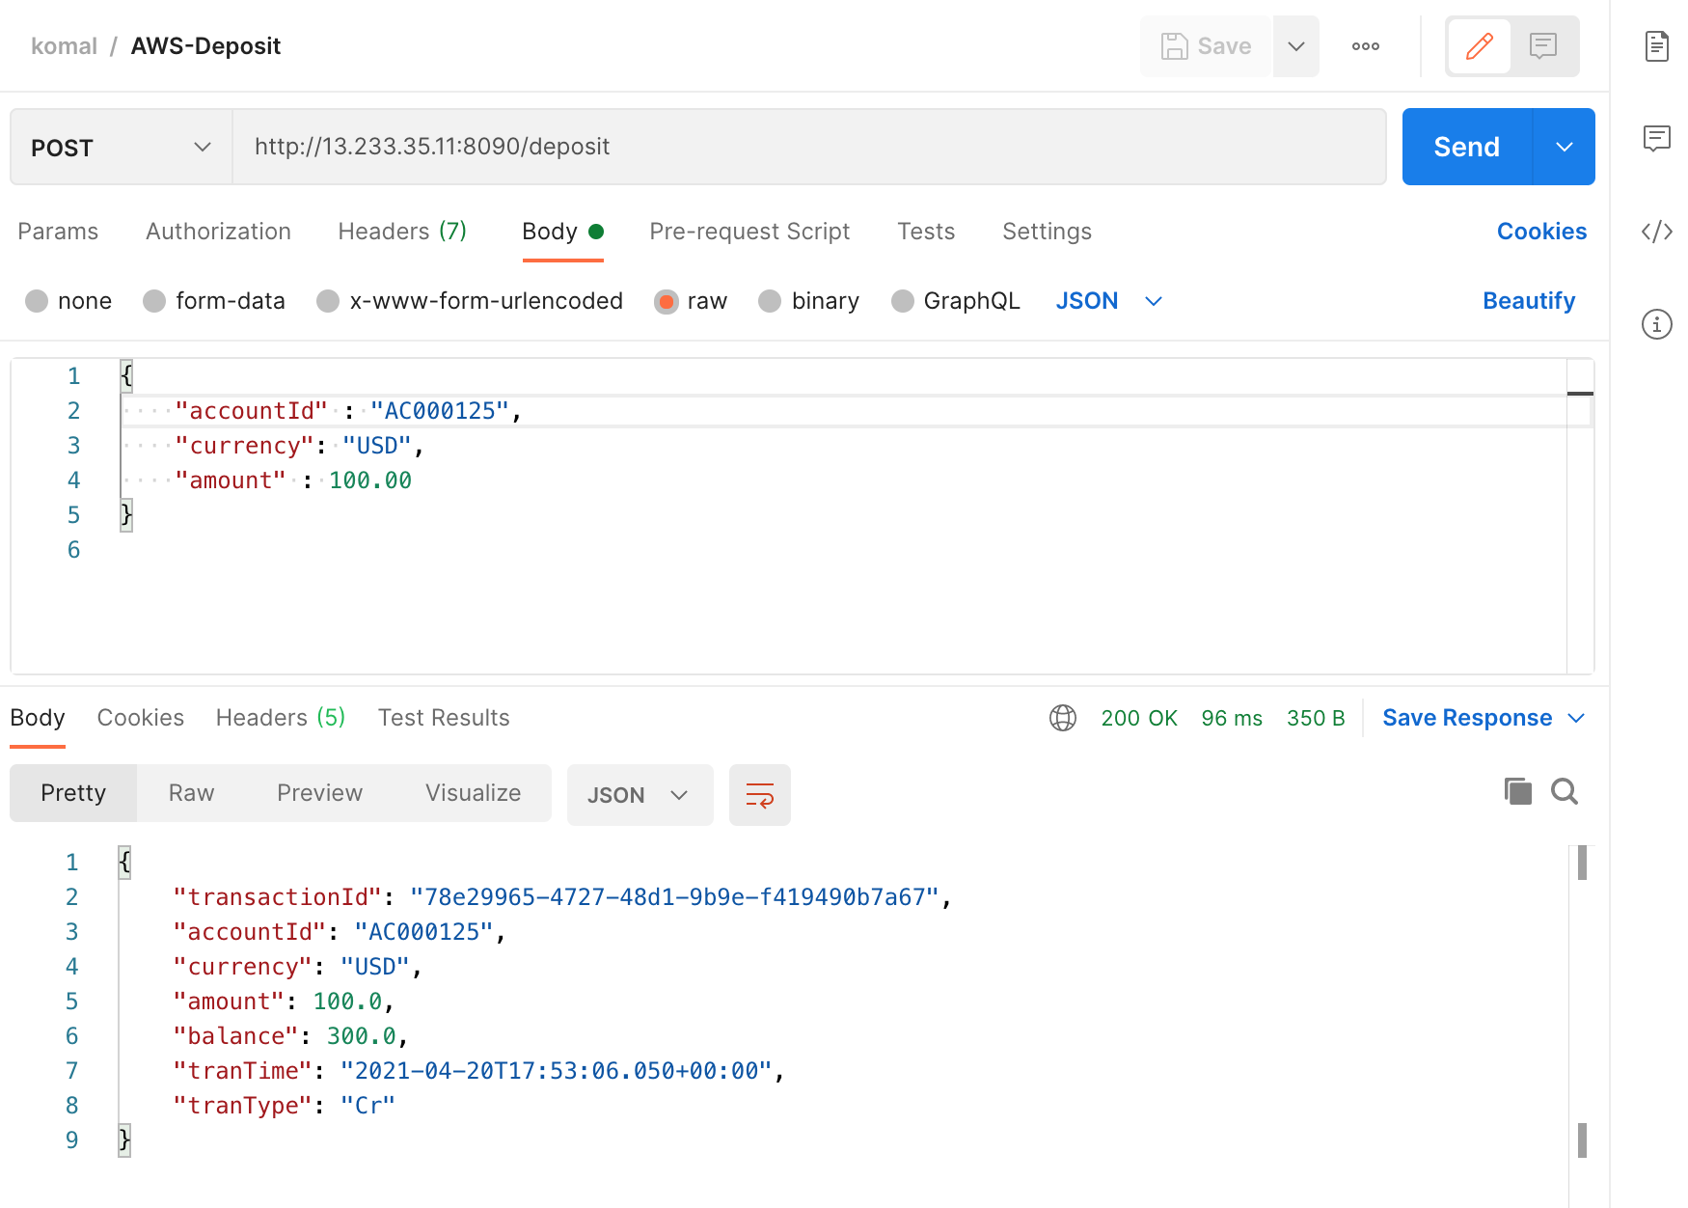

## Withdrawal Money

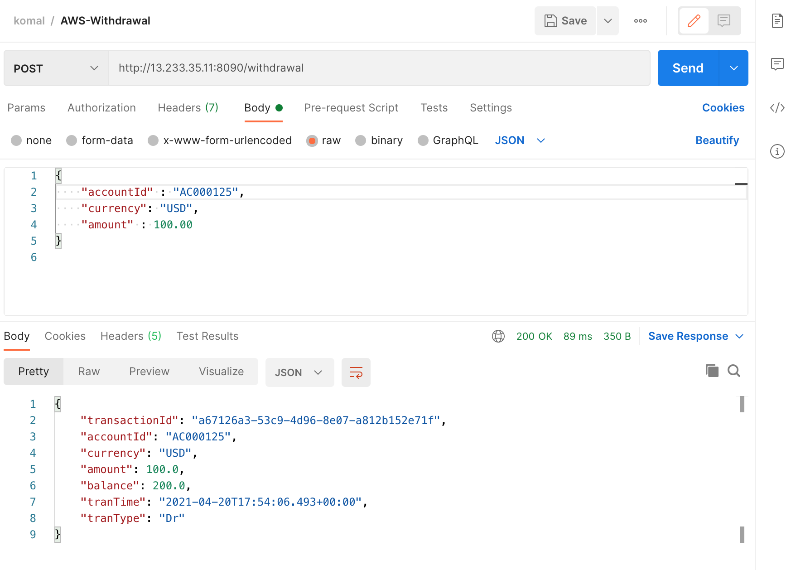

## Account Balance Inquiry

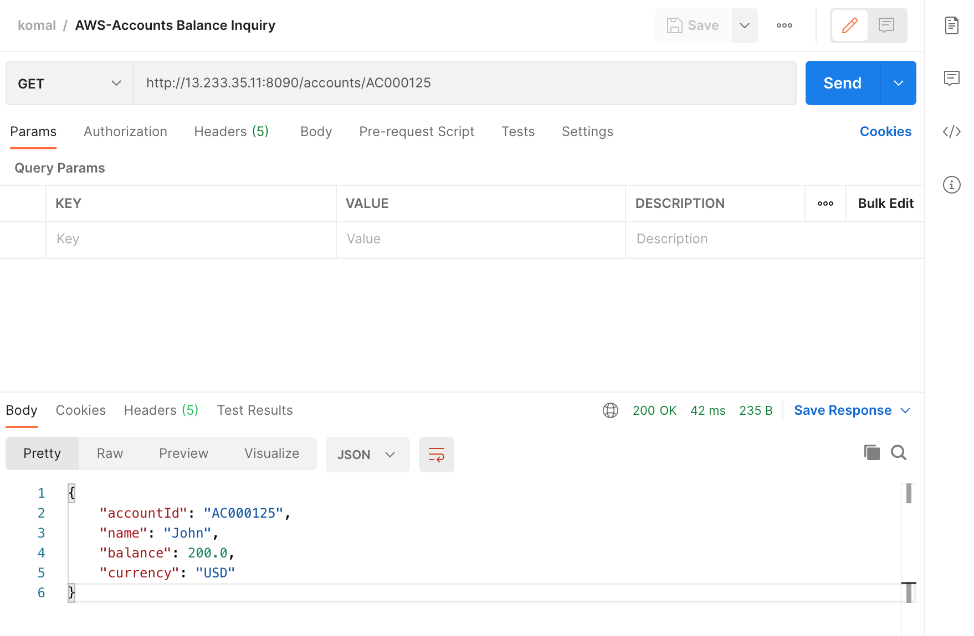

## jMeter Tool – Performance Measurement

jMeter Tool – for measuring the transaction API.

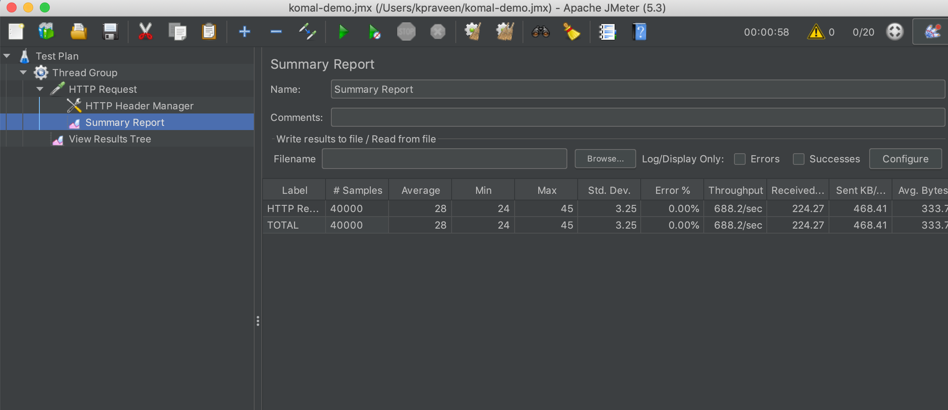

Average Response Time : 28ms

Throughput : 688 per second (20 concurrent users)

Error Percentage : 0

Number of requests tested : 40000

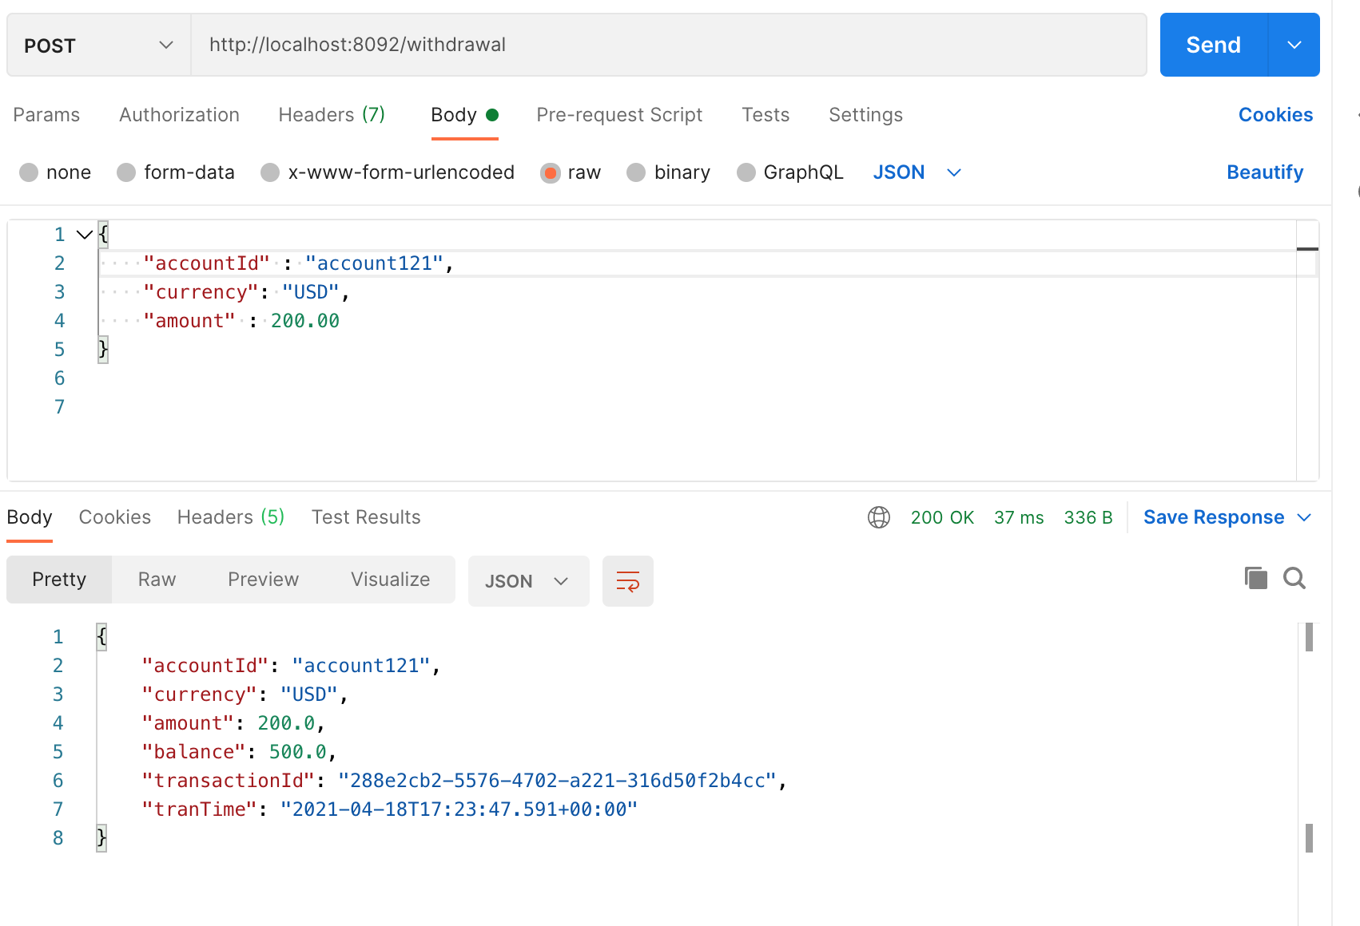

Above image shows the result using POSTMAN tool to test the API.

# References

1. <https://www.researchgate.net/publication/316217765_A_novel_method_for_evaluation_of_nosql_databases_A_case_study_of_cassandra_and_redis>
2. Latency is the New Outage (<https://redislabs.com/docs/latency-is-the-new-outage/>
3. <https://redis.io/>
4. <https://www.business-standard.com/article/economy-policy/digital-payments-rise-at-55-cagr-vy-volume-in-five-years-to-fy20-rbi-data-120101100400_1.html>
5. <https://www.investopedia.com/terms/a/accountbalance.asp>